9.2 Collision theory
Name: ____________________ Class: ____________________ Due date: 4.10
1. In separate experiments, a catalyst is added to a reaction mixture and the temperature of the mixture is decreased.
What are the effects of these changes on the rate of the reaction? （ ）
 | catalyst added | temperature decreased
A | faster | faster
B | faster | slower
C | slower | faster
D | slower | slower

2. Which graph shows the effect of increasing temperature on the rate of reaction of calcium carbonate with dilute hydrochloric acid? （ ）
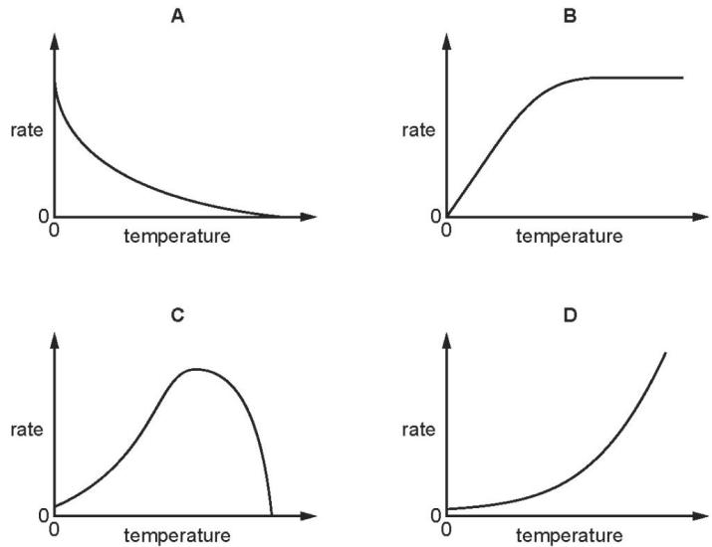

3. Which row explains why increasing temperature increases the rate of reaction（ ）
 | particles collide more often | particles collide with more energy
A | ✓ | ✓
B | ✓ | ×
C | × | ✓
D | × | ×

4 .Ethanoic acid reacts slowly with calcium carbonate.
Which statements explain why an increase in temperature increases the rate of the reaction? （ ）
1 The activation energy of the reaction is decreased.
2 There is an increase in collision rate.
3 The particles have more energy.
4 There will be fewer successful collisions.
A 1 and 2 B 1 and 3 C 2 and 3 D 2 and 4

6. The rate of reaction between magnesium and dilute hydrochloric acid is increased by increasing the concentration of the acid.
How does this affect the reacting particles? （ ）
 | collision rate of particles | proportion of particles with sufficient energy to react
A | increases | increases
B | increases | stays the same
C | stays the same | increases
D | stays the same | stays the same

7. A sample of dilute nitric acid is added to lumps of limestone in a conical flask. The conical flask is placed on a balance and the loss in mass is measured.
A second sample of nitric acid of a different concentration is separately tested. All other conditions are kept the same.
The loss in mass in 1 minute at each concentration of nitric acid is shown.
concentration in mol/dm³ | loss in mass in 1 minute/g
0.5 | 0.15
1.0 | 0.25

Which row describes and explains the results obtained using $1.0mol/{dm}^{3}$ nitric acid compared with $0.5mol/{dm}^{3}$ nitric acid? （ ）
 | description | explanation
A | decrease in reaction rate | decrease in particle collision energy
B | decrease in reaction rate | increase in particle collision rate
C | increase in reaction rate | increase in particle collision rate
D | increase in reaction rate | increase in particle collision rate and collision energy

8 .Which statements explain why increasing temperature increases the rate of a chemical reaction? （ ）
1 Heat makes the molecules move faster and collide more often.
2 Heat makes the molecules collide with more energy so they are more likely to react.
3 Increasing temperature lowers the activation energy for the reaction.
A 1 and 2 B 1 and 3 C 1 only D 2 only

9. Explain in terms of collisions between reacting particles why the increase of temperature increases the rate of reaction
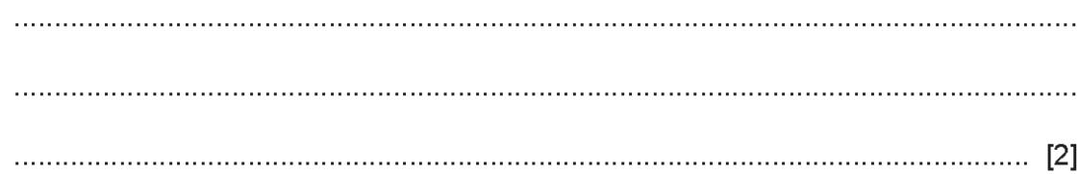

10. The effect of temperature on this reaction can be studied by the experiment shown below. Starch and iodine form a blue-black colour. Glucose and iodine do not form a blue-black colour.
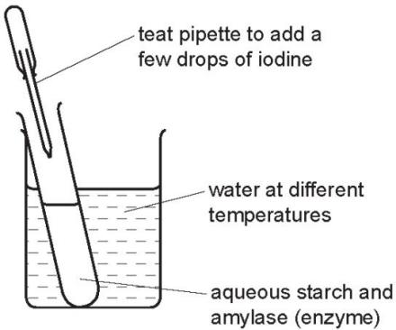
The experiment is set up as in the diagram and the time measured for the mixture to change from blue- black to colourless. The experiment is repeated at different temperatures. Typical results of this experiment are given in the table below.
experiment | temperature /℃ | time for blue-black colour to disappear /min
A | 20 | 30
B | 40 | 15
C | 70 | remained blue-black
Put the experiments in order of reaction rate - slowest first and fastest last.
.......................................................................................................................................
..................................................................................................................................[2]
Explain why the reaction rates in experiments A and B are different.
